

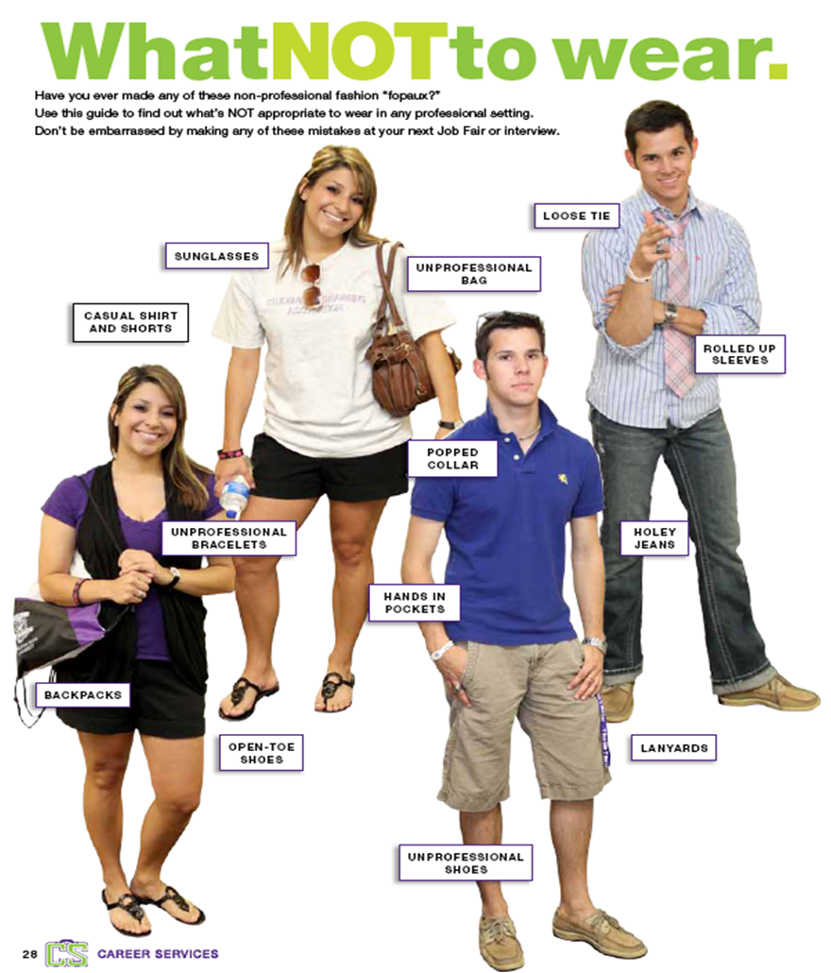

**Tips for Women**

* Conservative skirted suit in navy blue, dark brown or dark gray are best. Skirt length should be at or slightly above the knee.
* Blouse in white or ivory, long sleeve with modest neckline.
* Shoes match your suit. Clean and polished; heels no higher than 2 1/2 inches. No open-toed, open-heeled shoes.
* Wear natural looking make-up.
* No perfume/cologne. Clean bathed appearance.
* Subtle color nail polish.
* One pair of earrings, one ring on each hand, one necklace, professional-looking watch, one bracelet (Nothing dangling or distracting).

**Tips for Men**

* Suits - best colors are dark blue or navy solid, solid gray, blue/gray shadow plaid. First choice of material should be 100% wool. 2nd choice is polyester/wool blend. Avoid less than 45% wool.
* Shirts should be cotton or 65% polyester/35%cotton blend in white or solid colors. White shirts are best. They give the impression the wearer is intelligent, honest, and successful. NEVER wear short sleeves.
* 100% silk ties are the best in solid or small conservative patterns.
* No facial hair and a conservative haircut is preferable.
* No cologne. Clean bathed appearance.
* Limit rings one to each hand, professional-looking watch.